Question 1
Q. How are events handled in React compared to vanilla JavaScript? Explain the concept of synthetic events.
Ans : Event Handling Difference:
- In Vanilla JavaScript, Events Are Attached Directly To DOM Elements Using Methods Like addEventListener().
- In React, Events Are Written As CamelCase Attributes (e.g., onClick) Inside JSX And Passed A Function As The Event Handler.
Synthetic Events:
- React Wraps Native Browser Events In A Cross-Browser Wrapper Called SyntheticEvent.
- This Ensures Event Properties Work The Same Across All Browsers.
- Synthetic Events Have The Same Interface As Native Events But Are Managed By React For Performance And Compatibility.

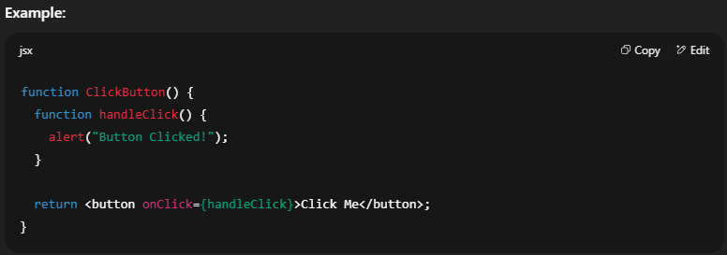

Question 2
Q. : What are some common event handlers in React.js? Provide examples of onClick, onChange, and onSubmit.
Ans : Common Event Handlers:
- onClick – Triggered When An Element Is Clicked.
- onChange – Triggered When Input Value Changes.
- onSubmit – Triggered When A Form Is Submitted.
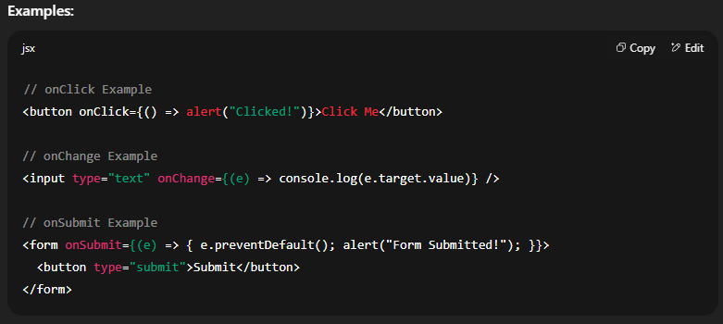

Question 3
Q. Why do you need to bind event handlers in class components?
Ans : Reason For Binding:
- In JavaScript Classes, The Value Of this Depends On How A Function Is Called.
- Without Binding, this Inside An Event Handler May Be undefined.
- Binding Ensures The Event Handler Has Access To The Correct this Referring To The Component Instance.
Ways To Bind Event Handlers:
- Binding In Constructor Using this.handler = this.handler.bind(this);
- Using Arrow Functions In Render Method.
- Using Class Field Syntax With Arrow Functions.
